CSA1413
COMPILER DESIGN
Name: Haresh Kumar N L
Reg No: 192425009
Identifier Validation

Aim:
To write a LEX program to check whether a given input string is a valid identifier or an invalid identifier.

Algorithm:
- Start the program.
- Include the required header file.
- Define a regular expression for a valid identifier.
- Read a string from the user.
- Check whether the string starts with a letter or underscore and contains only letters, digits, or underscores.
- If the string matches the pattern, print Valid; otherwise, print Invalid.
- Stop the program.

Pseudocode:
BEGIN
Read input string
IF string matches [A-Za-z_][A-Za-z0-9_]* THEN
Print "Valid"
ELSE
Print "Invalid"
END IF
END

Code:
%{
#include <stdio.h>
%}
%option noyywrap
%%
[A-Za-z_][A-Za-z0-9_]*\n? {
printf("Valid\n");
return 0;
}
[^\n]+\n? {
printf("Invalid\n");
return 0;
}
\n {
printf("Invalid\n");
return 0;
}
%%
int main(void)
{
printf("Enter an identifier: ");
yylex();
return 0;
}

Input:
@student12
student
Output:
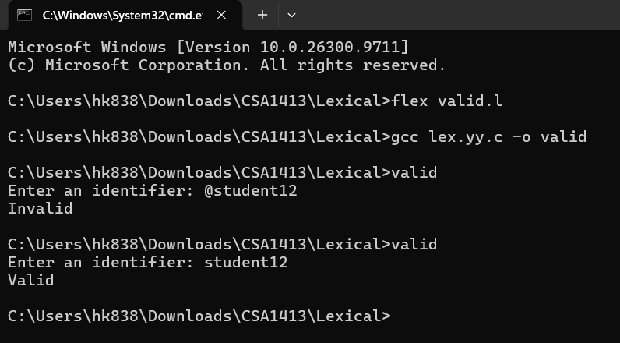

Result:
Thus, the LEX program to identify whether a given string is a valid or invalid identifier was written and executed successfully.

